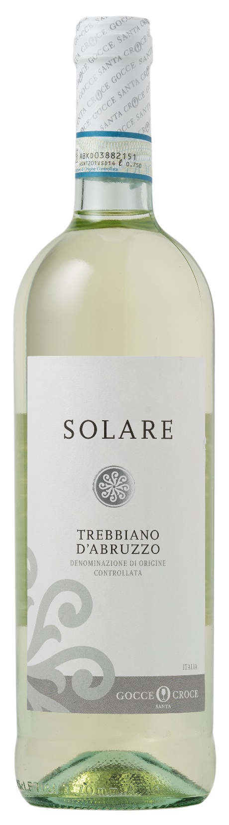
TREBBIANO ABRUZZO DOC – SOLARE

Grape: Trebbiano 100%
Alc. Vol.%: 12
Vintage: 2025
Residual sugar g/l: 5,0
Total acidity g/l: 5,9
Region: Abruzzi
Production zone: Vineyards in the area of Lanciano (Chieti)
Capacity: 750ml, 1500ml

CHARACTERISTICS

Vinification: After a soft pressing, fermentation in steel tanks at a controlled temperature
Aging: In steel tanks until bottling
Yield per ha: 14000kg
Colour: Bright and pale straw-yellow
Bouquet: Fresh with evident notes of fruits and flowers
Flavour: Smooth, fresh, rich and harmonious

SERVING SUGGESTIONS

Best enjoyed with light starters, soups, fish and white meat.
Serving temperature 8 °C
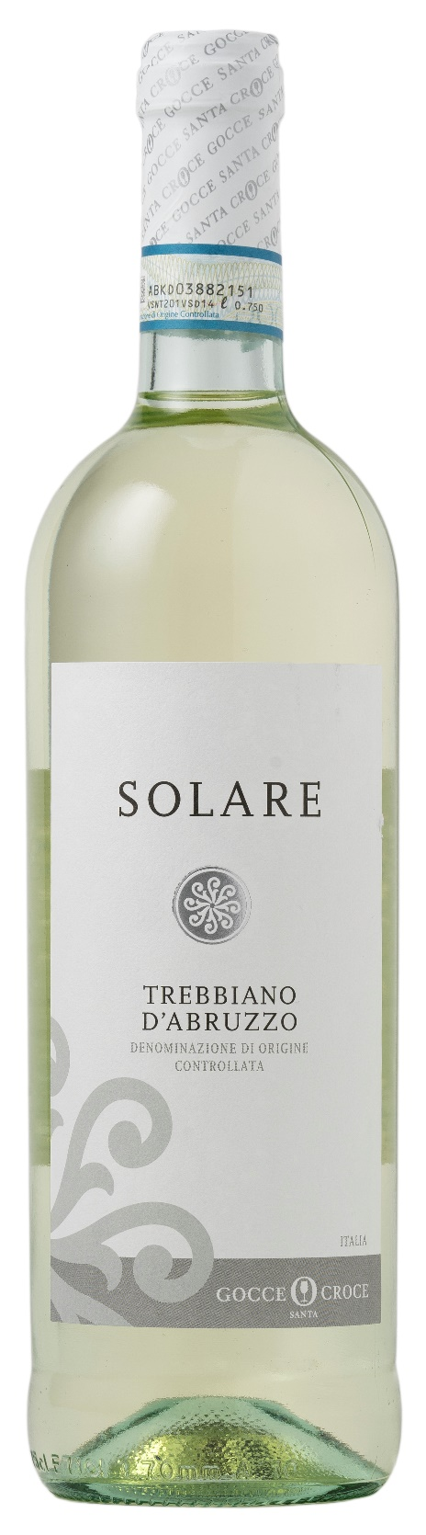
TECHNICAL INFORMATION / PALLETIZING

Size 750ml:
Article Nr. V08004A
GTIN-13 bottle 8017868003359
GTIN-13 carton 8017868004400
Closure Cork
Bottles / carton 6 bottles
Pallet size 80x120cm
Cartons/layer 25
Cartons/pallet 125
Kg/carton 7,3
Kg/pallet 895

Size 1500ml:
Article Nr. V08005B
GTIN-13 bottle 8017868003779
GTIN-13 carton 8017868003793
Closure Cork
Bottles / carton 6 bottles
Pallet size 80x120cm
Cartons/layer 14
Cartons/pallet 56
Kg/carton 13,5
Kg/pallet 790

Contains sulphites
GMO Free
Revisione 01. 14.05.2026

